Marketing Proposal



Client Info:

<<Client Name>>

<<Client Number>>

<<Client Email>>

Increasing Visibility and Influence

Through Digital

Marketing Strategies

+12088421478

[www.appsynergies.com](http://www.appsynergies.com/) [info@appsynergies.com](mailto:info@appsynergies.com)

AppSynergies Pvt Ltd, D-1602, Orchid Suburbia, Link Road, Kandivali West, Mumbai 400067, India

186 Malvern Avenue, Harrow, HA2 9HD, UK

Table of Contents

* Company Overview 3
* Our Services 4
* Our Approach 6
* Team Expertise 7
* Business Requirements & Project Overview 8
* Project Pricing 16
* Project Timeline 18
* Client Onboarding 19
* Terms & Conditions 20
* Client Testimonials 21
* Case Studies 22
* Contact Us 24



# Company Overview

###### Why Us?



|  |  |  |  |  |
| --- | --- | --- | --- | --- |
| **30k+** | **1B+** | **150+** | **100+** | **95%** |
| **Leads** | **Impressions** | **Marketing** | **Happy** | **Satisfied** |
| **Generated** | **Created** | **Projects** | **Clients** | **Clients** |



|  |  |  |  |  |
| --- | --- | --- | --- | --- |
| Best Digital Marketing | Genuine White Hat | Highest Leads Achieved | No.1 Performance | Best Ecommerce |
| Agency | SEO Service | By An Agency | Marketing Agency | Marketing Campaign |
| Awarded by IIM Skill | Awarded by GoodFirms | Awarded by 3 Best Rated | Awarded by EZ Rankings | Awarded by Silicon India |

About Us



Driving Growth Through Technology and Marketing. We help businesses thrive in the digital landscape. From crafting innovative AI-driven apps and websites to executing high-impact SEO, ASO, SMM, content, and email marketing strategies, we deliver measurable results that matter.

We specialize in Design, Development, Testing, Release & Project Management of AI driven apps & websites. We also specialize in Digital Marketing Services like SEO, ASO, SMM, Content & Email Marketing.

 Mission

To be a part of people's daily lives by helping them build lasting relationships in an environment of trust & respect.

 Vision

To be one of the leading technology & marketing companies in the world,

admired for its innovative products & services thereby contributing to a better & sustainable world.



## Our Services

Digital Marketing

We are an AI driven digital marketing agency empowering your business to innovate, optimize & grow in your market using AI-fuelled marketing strategies. Our team of experts has over 5 years of experience in the digital marketing industry.

SEO

Social Media Marketing Content Marketing



 PPC Advertising

 Email Marketing  Influencer Marketing

 Manual & AI Sales Service

AI Automations

At AppSynergies, we help you to transform your business with AI & drive growth. Automate repetitive tasks, boost productivity, and make smarter decisions with our powerful AI solutions!

 AI Calling  Chatbots

 Make Automations  GHL Automations

ManyChat Automations





App Design & Development

At AppSynergies, we build well-designed and optimized custom mobile applications with a delightful UX for both iOS and Android.

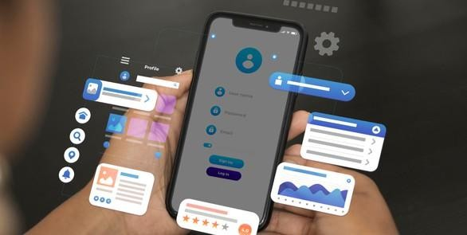iOS Android Flutter



 React JS

Firebase



Website Design & Development

At AppSynergies, we offer a complete range of website services that build up business value, from the initial idea and formulation of product strategy, through building a prototype and testing it with users, right to the creation of the product itself.

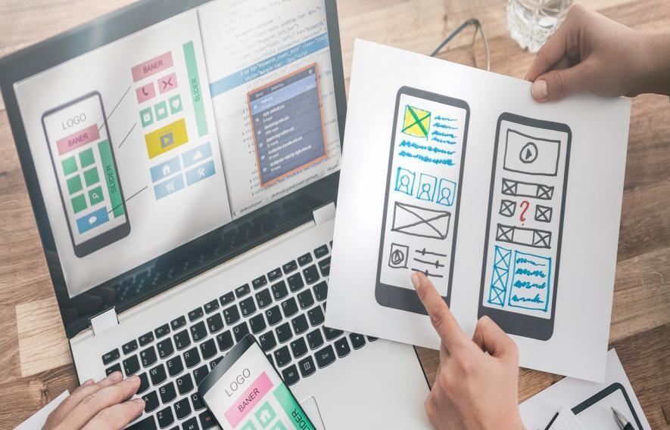Custom Website Design



E-Commerce Development Responsive Web Design Content



Management System (CMS) Web

Maintenance & Support



## Our Approach

#### Digital Services

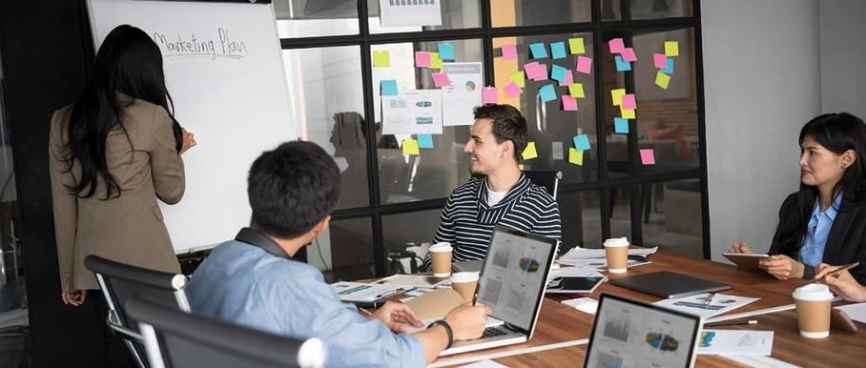

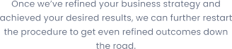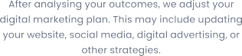

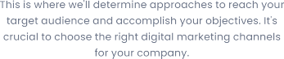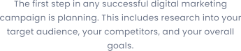

We begin by researching your industry and audience to create a tailored strategy. Our creative team crafts visually stunning posts. We implement marketing strategies to increase your online visibility.



## Team Expertise



Our team comprises of experts in various technical & marketing fields with approximately 5 - 10 years of experience & knowledge in delivering complex projects.

You will have the below list of experienced professionals working on your project:

* Digital Marketing Executive - <<DME>>
* Digital Marketing Associate - <<DMA>>
* Business Analyst – <<BA>>
* Graphics Designer - <<GD>>



### Business Requirement & Project Overview



Marketing Strategy:

1. **Market Analysis:** We will conduct extensive market research to understand the dynamics of industry, including current trends, growth opportunities and challenges.
2. **Niche Analysis:** We will analyse niche markets within the industry where you can establish a unique selling proposition (USP) and

cater to specific consumer needs that are currently underserved by competitors.

1. **Competitor Analysis:** We will identify and analyse key competitors in the sector, examining their offerings, pricing strategies,

marketing tactics and customer engagement methods.

1. **SWOT Analysis:** We will perform a SWOT (Strengths, Weaknesses, Opportunities, Threats) analysis for each competitor to identify gaps and opportunities that you can leverage to gain a competitive

advantage.



Email Marketing (Mailchimp):

1. **Campaign Strategy & Objective Setting:** We will define the

purpose and objectives of your email marketing campaign, nurturing leads, promoting a new package, or driving website traffic. Each

campaign will be aligned with your broader business goals, ensuring a strategic approach to engaging your target audience. Campaign objectives may differ according to our advertising strategy.

1. **Template Design & Content Creation:** We will create visually appealing and responsive email templates in Mailchimp that reflect your brand identity. High-quality content, including attention- grabbing subject lines, persuasive copy, and clear calls-to-action (CTAs), will be developed to encourage recipient engagement and drive conversions.
2. **Email Automation Setup:** Automation workflows will be designed and implemented to deliver personalized and timely emails based on subscriber behaviour.
3. **Campaign Testing & Optimization:** Before launching, each email will undergo rigorous testing for design, layout, and functionality on different devices and email clients. A/B testing of subject lines,

CTAs, and visuals will be conducted to identify the most effective elements and improve overall campaign performance.

Monthly Maintenance & Reporting:

1. **Campaign Summary Preparation:** We will compile a

comprehensive summary of campaign performance for the reporting period.

1. **Ad Performance Analysis:** We will analyse detailed ad

performance metrics to assess effectiveness and impact. We will provide an overview of key metrics including reach, impressions, engagement rates, leads conversions and CPC.



## Project Pricing

|  |  |  |  |
| --- | --- | --- | --- |
| **Description** | **Task** | **Pricing** | **Type** |
| Marketing Strategy | Research & Plan Timelines | <<MS>> | One Time Fee |
| Email Marketing | Mailchimp (500 Emails) | <<EM>> | Monthly Recurring Fee |
| Monthly maintenance & Reporting | Social media reporting and ads reporting | <<MR>> | Monthly Recurring Fee |

|  |  |
| --- | --- |
| **Total Marketing** | **<<Total>>** |

***Note****: The Ad Budget should be spent by you. You have to allocate the amount that you want to spend for the entire month.*



##### Payment Method

AppSynergies Pvt Ltd accepts the following payment method:

* Bank Transfer
* Credit Cards and Debit Cards
* Net Banking
* Gpay or Paytm

##### Payment Schedule

|  |  |  |
| --- | --- | --- |
| **Sr No.** | **Schedule** | **Amount** |
| 1 | Instalment 1 (Has to be paid before start of the project) - One-time fee | <<Instalment 1>> |
| 2 | Instalment 2 (Has to be paid once we set up the social media handles) - It’s a monthly recurring cost | <<Instalment 2>> |

**Note:** We are happy to offer 10% discount if you can sign the contract & start the project within 48 hours.

Next Steps:

Our proposal is valid for a week. To take advantage of this proposal and proceed with the project as outlined, the client next step must be to:

* Accept the proposal as-is
* Discuss desired changes with AppSynergies Pvt Ltd.
* Finalize and sign the contract
* Submit an initial payment as mentioned in the payment schedule section

Once completed, AppSynergies Pvt Ltd will connect you to schedule project launch meeting to make introductions and gather information before beginning the work.

We are happy to make changes to the project scope on your request at any time but this may be subject to additional billing.



## Project Timeline

* 3-5 Days  Marketing Strategy
* 1-2 Days Social Media



Channel & Ad Account Setup

* 3-5 Days Creative Posts



(10 per Month)

* 30 Days Paid Ads

(Meta + Google)

* 30 Days  Email Marketing
* 30 Days  SEO
* 30 Days Monthly Reporting





## Client Onboarding



* **Initial Consultation**: We schedule a meeting to discuss your goals, needs, and expectations.
* **Proposal Presentation**: We present our tailored proposal, including pricing and project details.
* **Project Kickoff**: Once you approve the proposal, we initiate the project, assigning a dedicated team.
* **Regular Updates**: We provide regular progress updates and milestones.
* **Project Completion**: Upon project completion, we conduct thorough testing and hand over all deliverables.
* **Ongoing Support**: We offer post-launch support and assistance as needed.



## Terms & Conditions

Once the project fee is paid in full to AppSynergies Pvt Ltd, any elements of text, graphics, photos, contents, trademarks, or other artwork furnished to the client for inclusion in the website are owned by the client. AppSynergies Pvt Ltd assumes the client has permission from the rightful owner to use any code, scripts, data, and reports provided by the client for inclusion in its materials, and will hold harmless, protect, and defend AppSynergies Pvt Ltd from any claim or suit arising from the use of such work.

AppSynergies Pvt Ltd retains the right to display graphics and other web content elements as examples of their work in their portfolio and as content features in other projects. This agreement becomes effective only when signed by the client and AppSynergies Pvt Ltd. Regardless of the place of signing of this agreement, the client agrees that for purposes of venue, this contract was entered into in Mumbai, India and any dispute will be litigated or arbitrated in Mumbai, India.

The agreement in this contract constitutes the sole agreement between the client and AppSynergies Pvt Ltd regarding all items included.

**This proposal shall be valid until <<VDate>>**

**Feel free to reach out to us at** [info@appsynergies.com](mailto:info@appsynergies.com) **or +91-9967067419 for any questions.**

**Signature Details**

Sneha Shukla

|  |  |
| --- | --- |
| <<Client Name>> | Sneha Shukla |
| <<Date>> | <<Date>> |

We look forward doing business with you.

Thank You, Team AppSynergies



## Client Testimonials

MingleWise

“Appsynergies has been instrumental in driving the growth of MingleWise’s app subscriptions. Their targeted digital marketing campaigns helped us enhance our social media presence, boost engagement, and achieve significant user

acquisition. The team’s strategic approach and expertise delivered excellent results, making a notable impact on our business.”



Al Dar Physiotherapy Clinic

“Working with Appsynergies has greatly enhanced Aldar Physiotherapy Clinic’s online presence. Their strategic approach to digital marketing helped us increase patient inquiries, improve our local search visibility, and drive more traffic to our website. The team’s expertise in optimizing campaigns has resulted in a significant return on investment.

Highly recommended!”

 Stylish-sara (E-Commerce)

“Appsynergies has been a cornerstone in

establishing and growing Stylish Sara’s e-commerce business from the ground up. Their strategic digital marketing initiatives have helped us build a strong online presence, attract the right audience, and convert them into loyal customers. Their expertise and dedication have been instrumental in driving

our business growth across the UAE and the US.”

Sohan Jewellers

“Appsynergies significantly boosted Sohan Jewellers’ Instagram presence and helped us attract a steady stream of high-quality leads. Their targeted campaigns and strategic approach enhanced our website traffic and delivered a strong return on

investment.”

Property Dictionary

“Appsynergies has played a pivotal role in the

growth of Sara Reality’s business. Their expertise in digital marketing helped us increase our online visibility and attract more qualified leads. Through their targeted campaigns and engaging content, we saw a remarkable transformation in how we connect with potential buyers and convert site visits into sales. The results speak for themselves, and we are extremely satisfied with the outcomes.”

 Craft N Skill Studio

“Appsynergies has been a key partner in growing Craft N Skill Studio’s online presence. Their expertise in Instagram marketing helped us increase engagement, attract new followers, and generate a significant number of workshop inquiries. Their targeted campaigns and strategic approach led to a remarkable return on investment. Highly

recommended!”



## Case Studies

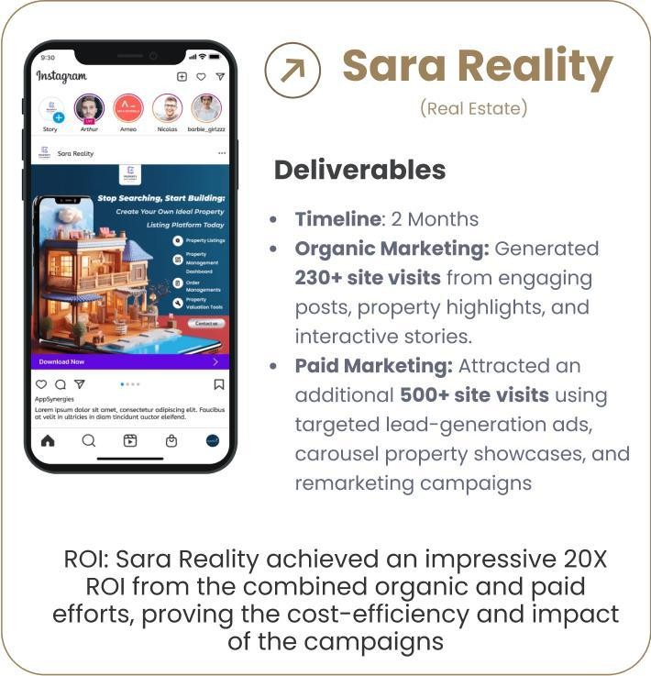

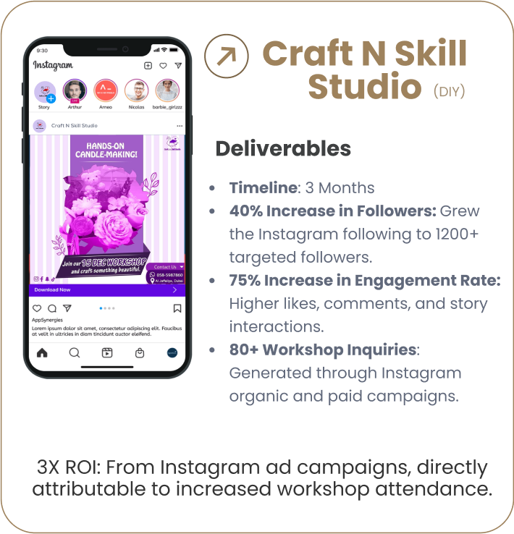







## Contact Us

Website <https://appsynergies.com/>

Phone +12088421478

[](https://www.facebook.com/appsynergies)E-Mail [info@appsynergies.com](mailto:info@appsynergies.com)



Social Media

 Address 186 Malvern Avenue, Harrow, HA2 9HD, UK. D-1602, Orchid Suburbia, Link Road, Kandivali West, Mumbai 400067, India